**IBM Electromatic**

IBM Electromatic

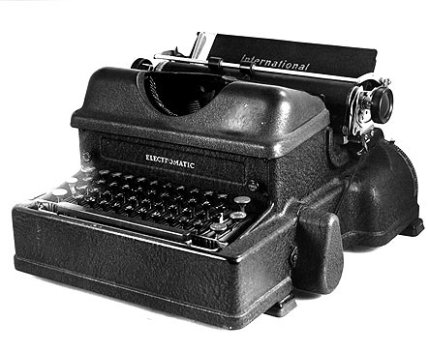

IBM Electromatic是世界上第一款成功商务电子打字机，这款打字机在1946年问世，目前IBM老员工至今仍在应用，以每分钟可以打出216个字而著称。

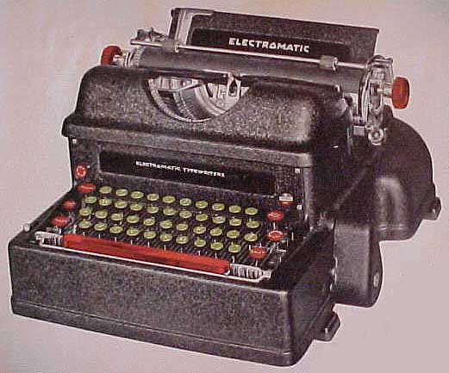

International **Electromatic** (1941)

The history of the Electromatic goes back to 1924, when the North East Electric Company received patent rights for the power roller from James Smathers. At that time, the company was selling electric motors, and wanted to get into the typewriter business.

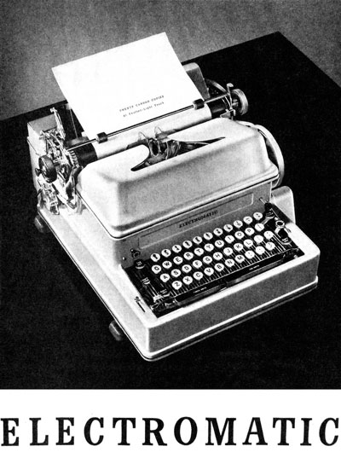

They reached an arrangement with Remington, securing a contract for 2,500 machines in 1925. N. E. Electric manufactured the motor and power-roller base. The typewriter portion was made by Remington, based on its model Number 12. Remington had to do little more than attach its typewriter to the base.

All the units manufactured sold quickly and Remington wanted to continue the relationship. According to Darryl Rehr, in his 1997 book, "Antique Typewriters & Office Collectibles", Remington claimed ... they could sell as many as N.E. Electric could produce."[1] The insistence of N.E. Electric on a contract, however, came at a time when Remington was unable to make such a commitment, so the Remington Electric went out of production.

The N. E. Electric Company then developed and produced the Electromatic, placing it on the market in 1929. After passing through the hands of General Motors, it became The Electromatic Typewriter Co. In 1933, IBM purchased this company and sold its Electromatic as the Model 01.

The IBM Electromatic typewriter was the first electric typewriter to enjoy long-term commercial success. Unlike the later IBM Selectric typewriter, this typewriter model used a conventional moving carriage and typebar mechanism.

图说[回目录](http://www.techcn.com.cn/index.php?doc-view-140652.html" \l "section)

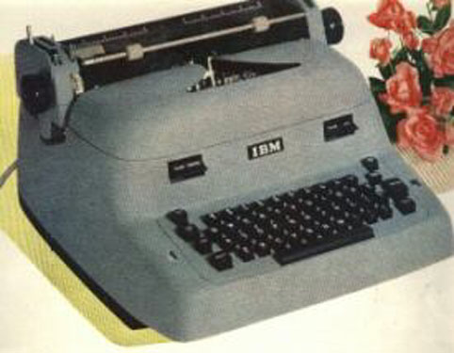

**IBM** Electric Typewriter, 1951 ad

相关链接[回目录](http://www.techcn.com.cn/index.php?doc-view-140652.html" \l "section)

• "[IBM Electromatic Typewriter](http://www-03.ibm.com/ibm/history/exhibits/vintage/vintage_4506VV2240.html)". <http://www-03.ibm.com/ibm/history/exhibits/vintage/vintage_4506VV2240.html>.

• [Model 01 IBM typewriter - actual advertisements](http://www.etypewriters.com/01thumb.htm)

• [Model 04 IBM typewriter - actual advertisement](http://www.etypewriters.com/1947-04.jpg)

• [The origin of the Electromatic Typewriter](http://www.etypewriters.com/remingtom.htm)

参考文献[回目录](http://www.techcn.com.cn/index.php?doc-view-140652.html" \l "section)

http://en.wikipedia.org/wiki/IBM_Electromatic_typewriter